| **Full name** | **ID** | **Email** |
| --- | --- | --- |
| Lê Phạm Quang Huy | 2151015 | huy.lepq2501@hcmut.edu.vn |
| Nguyễn Minh Khang | 2151095 | khang.nguyenk21@hcmut.edu.vn |
| Nguyễn Hoàng Đăng Khoa | 2151213 | khoa.nguyenbku0906@hcmut.edu.vn |
| Hồ Cao Nhật Linh | 2151024 | linh.hocaonhat@hcmut.edu.vn |

1. **Block Diagram**

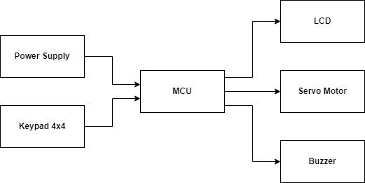

1. **Hardware selection**

| **Components** | **Quantity** | **Reason** |
| --- | --- | --- |
| Atmega32 | 1 | - Atmega32 has SCL, SDA ports for I2C interface with the LCD  - Atmega32 has RXD, TXD ports for UART interface with the CP2102  - Atmega32 has I/O ports to interact with the 4x4 Matrix Keypad  - Atmega32 is easily purchased at an acceptable price. |
| Green LCD Text LCD1602 | 1 | - The Green LCD Text LCD1602 is easily purchased at an acceptable price.  - The Green LCD Text LCD1602 has SCL, SDA ports for I2C interface with Atmega32. |
| 4x4 Matrix Keypad | 1 | - The Matrix Keypad is easily purchased at an acceptable price. |
| RC Servo MG90S Motor | 1 | - The Servo Motor is easily purchased at an acceptable price. |
| USB to UART circuit CP2102 | 1 | - CP2102 can be used to upload C-based code from Microchip Studio to Atmega32.  - CP2102 can be the power supply of the system because the USB port takes the voltage directly from the connected laptop.  - CP2102 has RXD, TXD ports for UART interface with Atmega32.  - CP2102 is easily purchased at an acceptable price. |

1. **Schematic explanation**

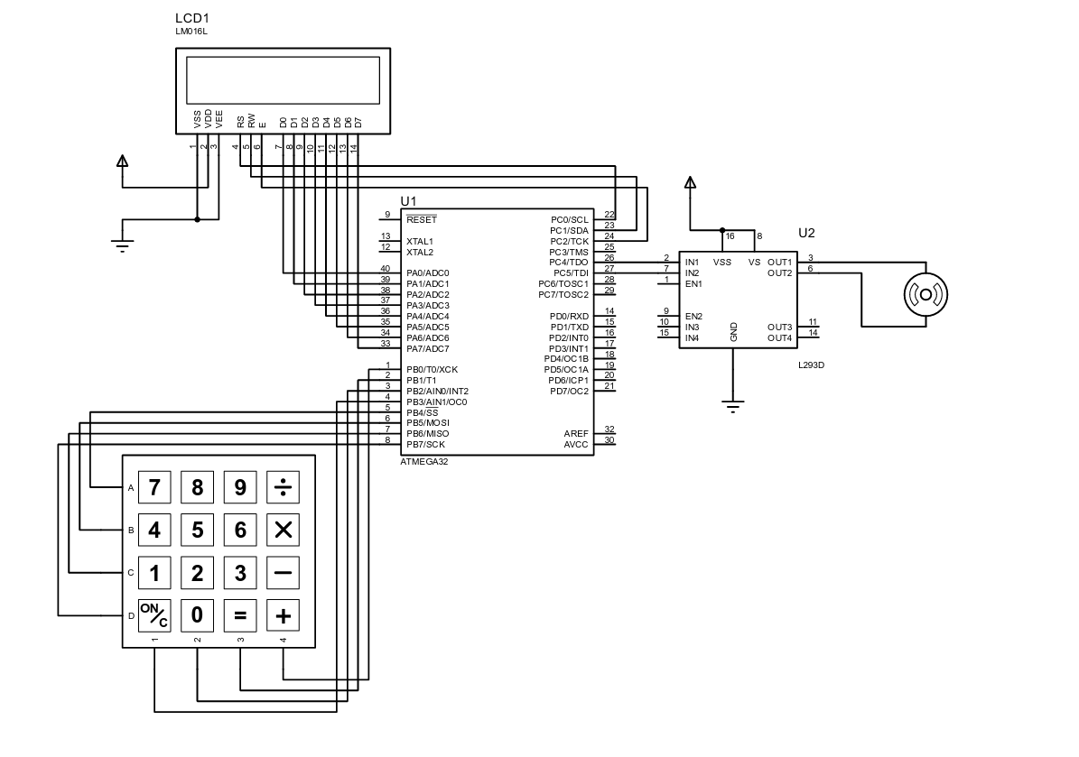

Atmega32 microcontroller receives user input from the 4x4 keypad connected to PORTB. The entered password is then displayed on the 16x2 LCD controlled via PORTA and pins PC0-PC2. Upon receiving the complete password, the microcontroller checks it against a stored value. If correct, it rotates the motor through pins PC4 and PC5 to unlock the door. If incorrect, an error message appears on the LCD.

1. **Schematic (PDF)**

Attached with the file